EX. NO: 1

IMPLEMENTATION OF CAESAR CIPHER

AIM:
To implement the simple substitution technique named Caesar cipher using C language.

ALGORITHM:
STEP-1: Read the plain text from the user.
STEP-2: Read the key value from the user.
STEP-3: If the key is positive then encrypt the text by adding the key with each
character in the plain text.
STEP-4: Else subtract the key from the plain text.
STEP-5: Display the cipher text obtained above.

PROGRAM:
#include <stdio.h>
#include <string.h>
#include <ctype.h>

int main()
{
char plain[100], cipher[100];
int key, i, length;

printf("Enter the plain text: ");
scanf("%s", plain);

printf("Enter the key value: ");
scanf("%d", &key);

length = strlen(plain);

for(i = 0; i < length; i++)
{
if(isupper(plain[i]))
{
cipher[i] = ((plain[i] - 'A' + key) % 26) + 'A';
}
else if(islower(plain[i]))
{
cipher[i] = ((plain[i] - 'a' + key) % 26) + 'a';
}
else
{
cipher[i] = plain[i];
}
}

cipher[length] = '\0';

printf("\nPLAIN TEXT : %s", plain);
printf("\nENCRYPTED TEXT : %s", cipher);

return 0;
}
OUTPUT:
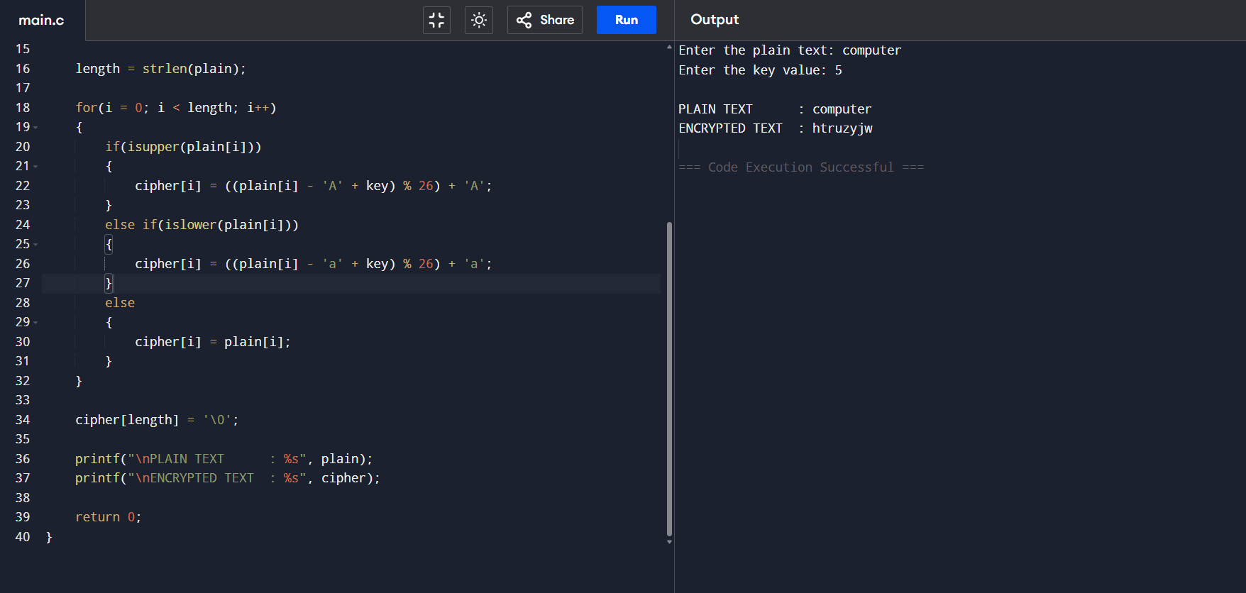

RESULT:
Thus the implementation of Caesar cipher had been executed successfully.

